Action: Go to the log-in page

Steps: Click on login page

Expected Results: Login page appears.

Pass/Fail: Pass

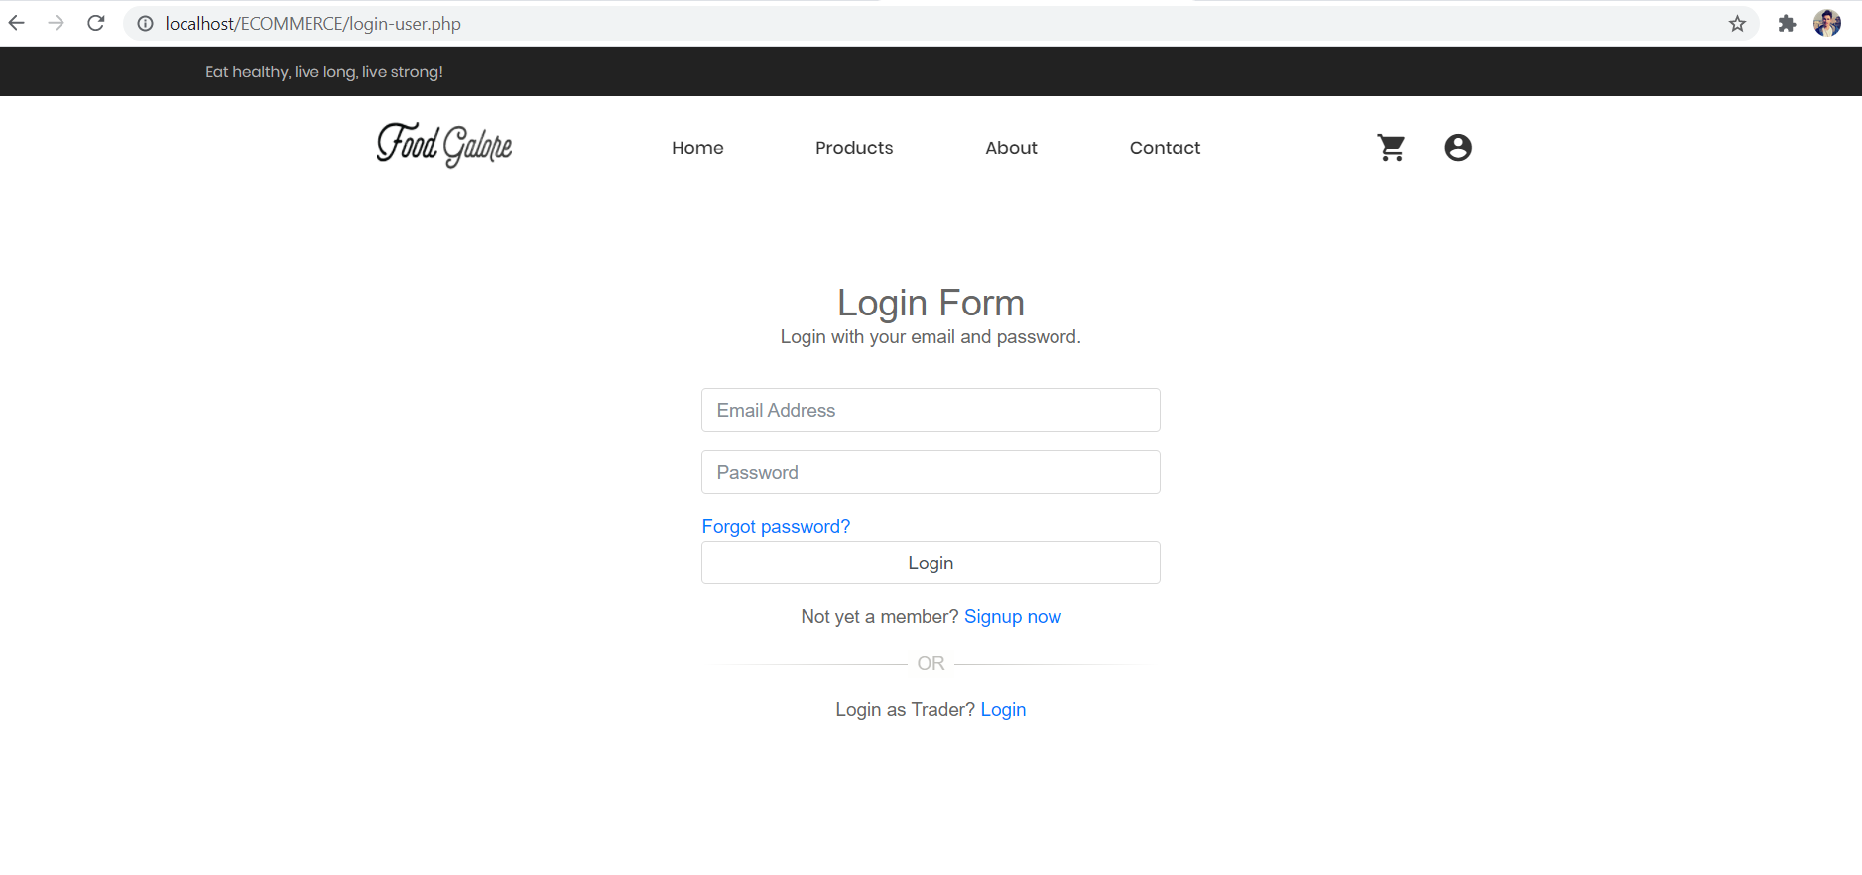

Action: Incorrect password

Steps: Input wrong login details.

Expected Results: Incorrect email and password message pops up.

Pass/Fail:Pass

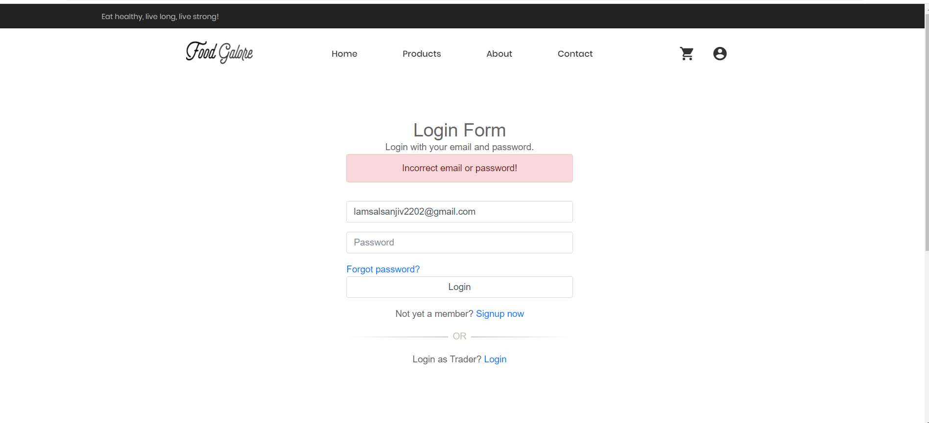

Action: Sign up

Steps: Click on signup now after clicking on the login page.

Expected Results: Signup page appears.

Pass/Fail:Pass

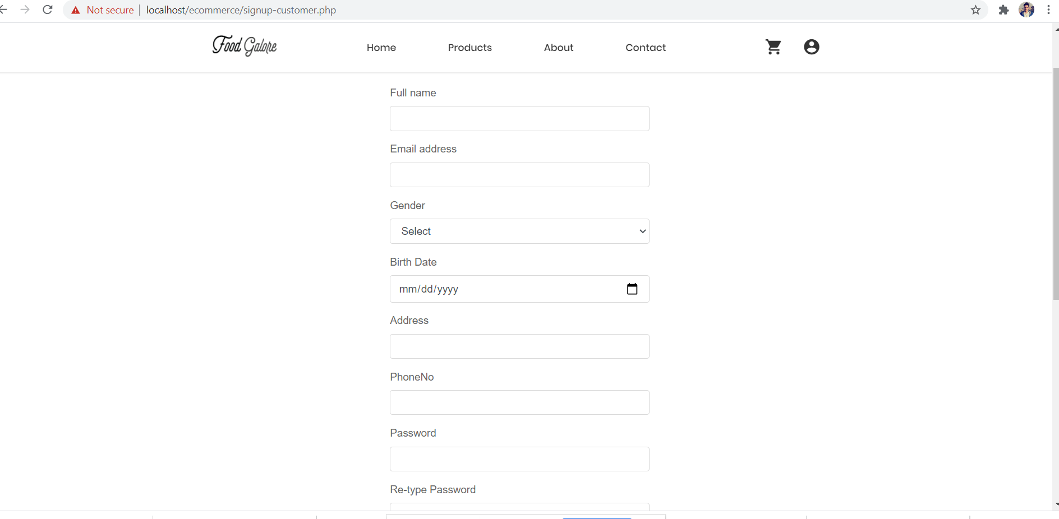

Action: Password repeat error

Steps: Input non matching passwords.

Expected Results:Passwords don't match, message pops up.

Pass/Fail: Pass

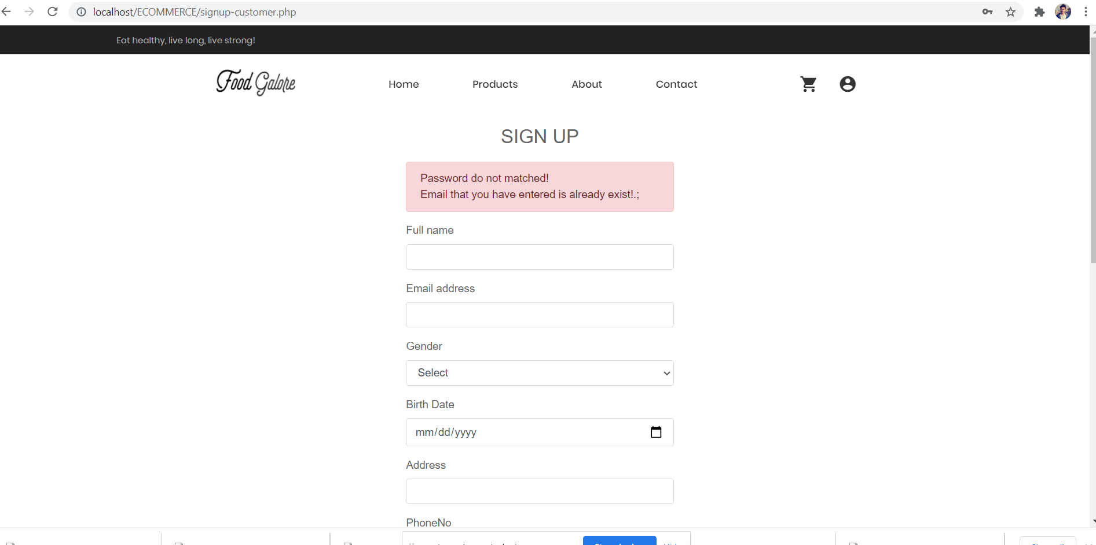

Action: Correct password and email sign up

Steps: Fill all details correctly.

Expected Results: Verification code page appears.

Pass/Fail:Pass

Action: Verification code

Steps: Filling all details correctly in signup page

Expected Results

Pass/Fail: Pass

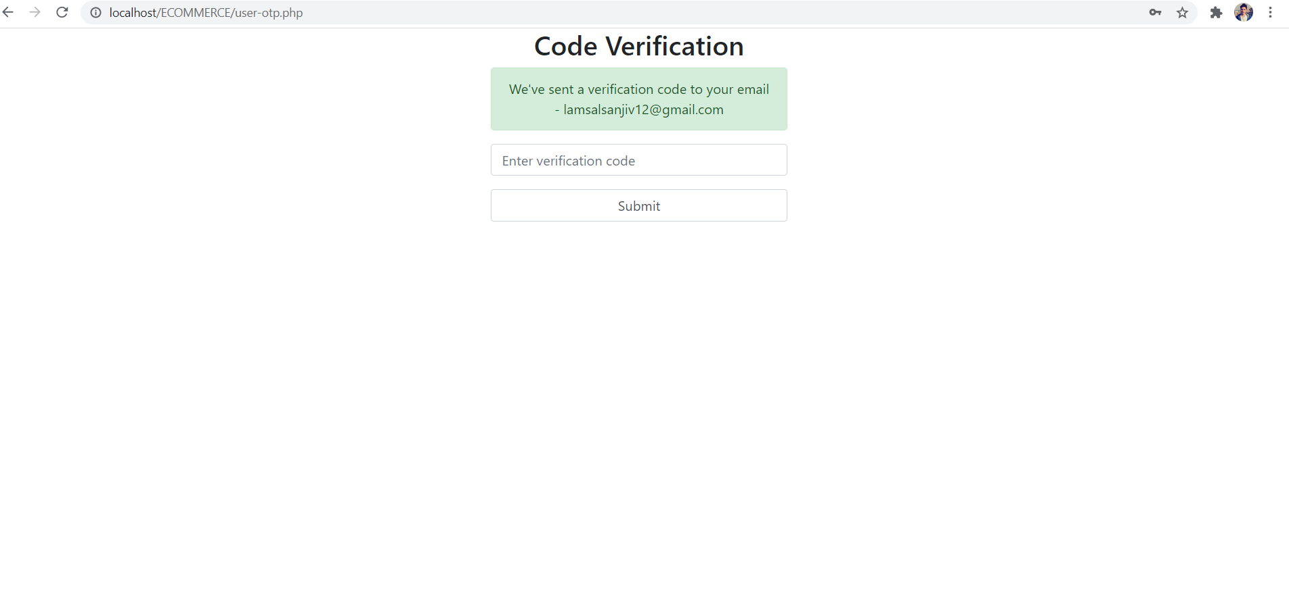

Action: Email verification code

Steps: Open email and check verification code.

Expected Results: Verification code appears.

Pass/Fail: Pass

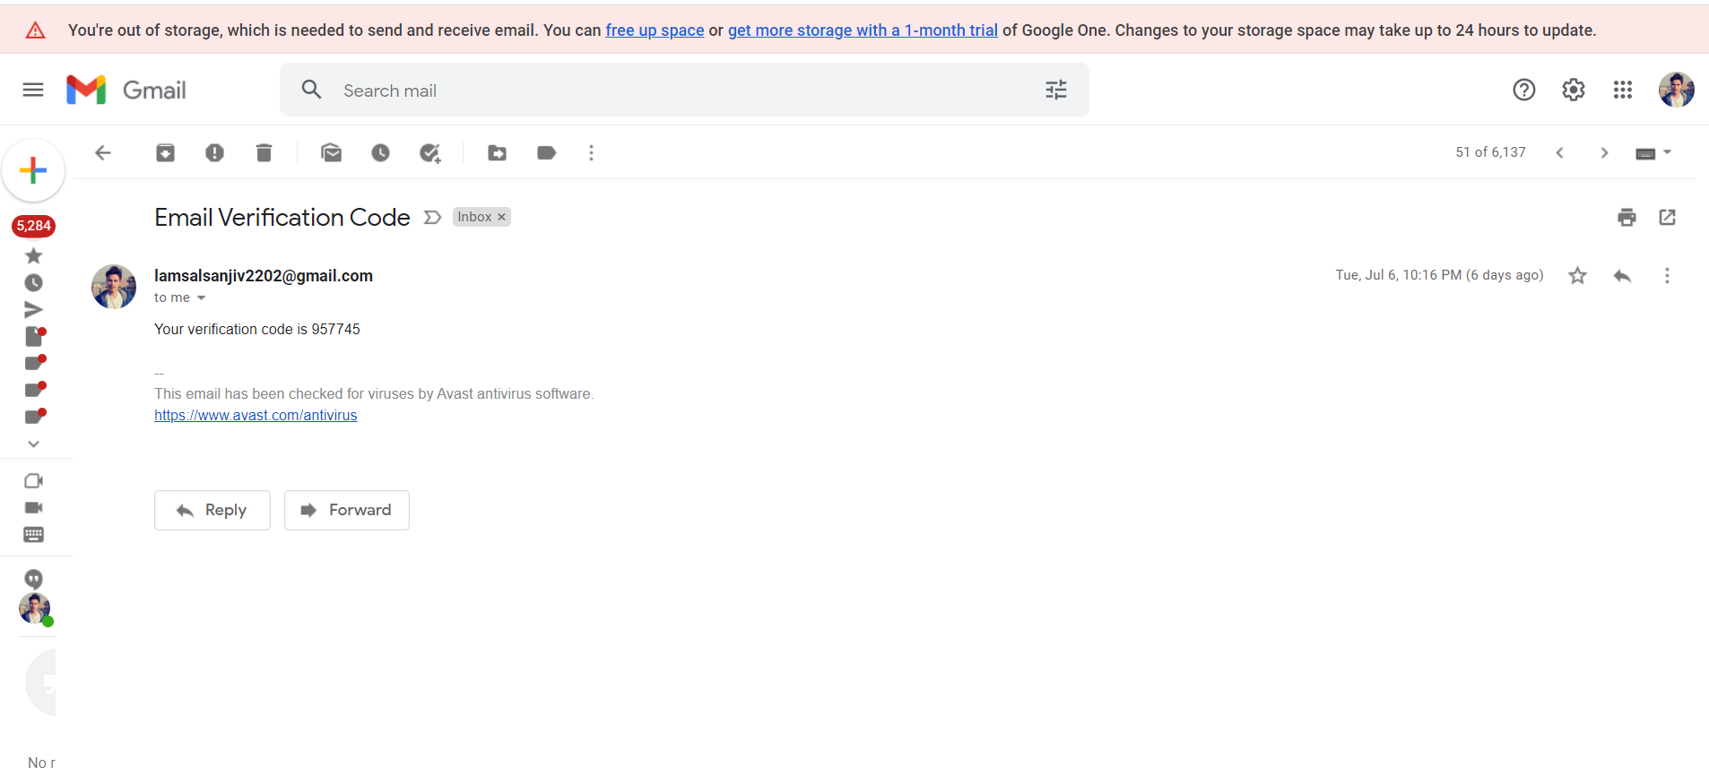

Action: Homepage

Steps: Open website

Expected Results:Homepage opens up.

Pass/Fail: Pass

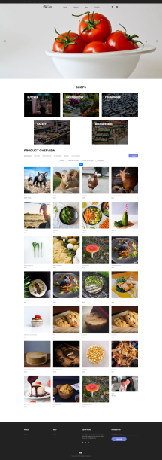

Action: Product page

Steps: Click on product page

Expected Results: Product page appears

Pass/Fail: Pass

Action: About Page

Steps: Click on about page

Expected Results:You will be directed to the us page.

Pass/Fail:Pass

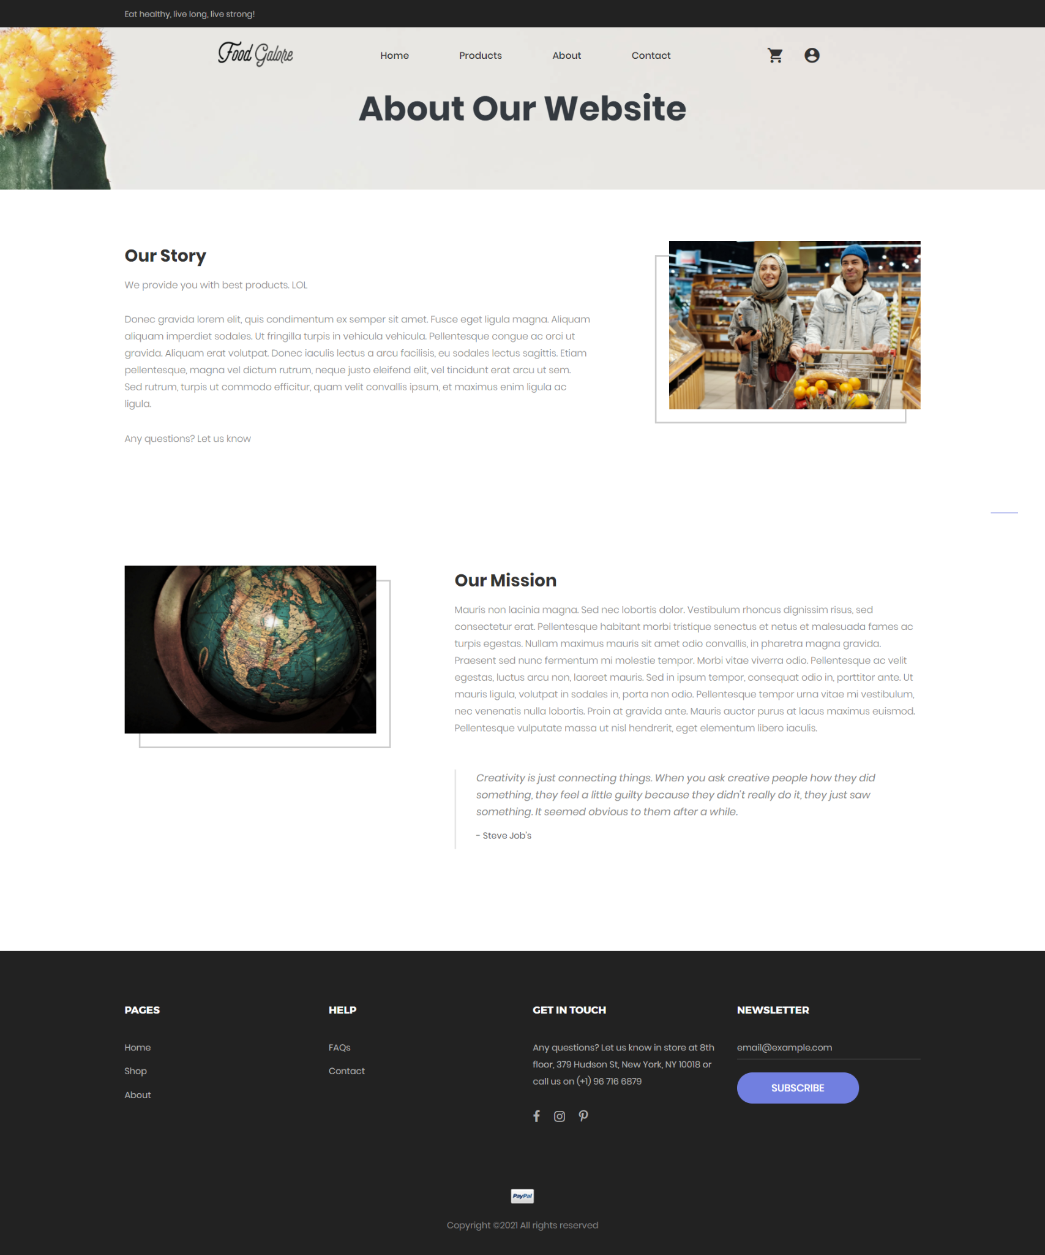

Action: Contact page

Steps: Click on Contact page

Expected Results: You will be directed to contact page.

Pass/Fail:Pass

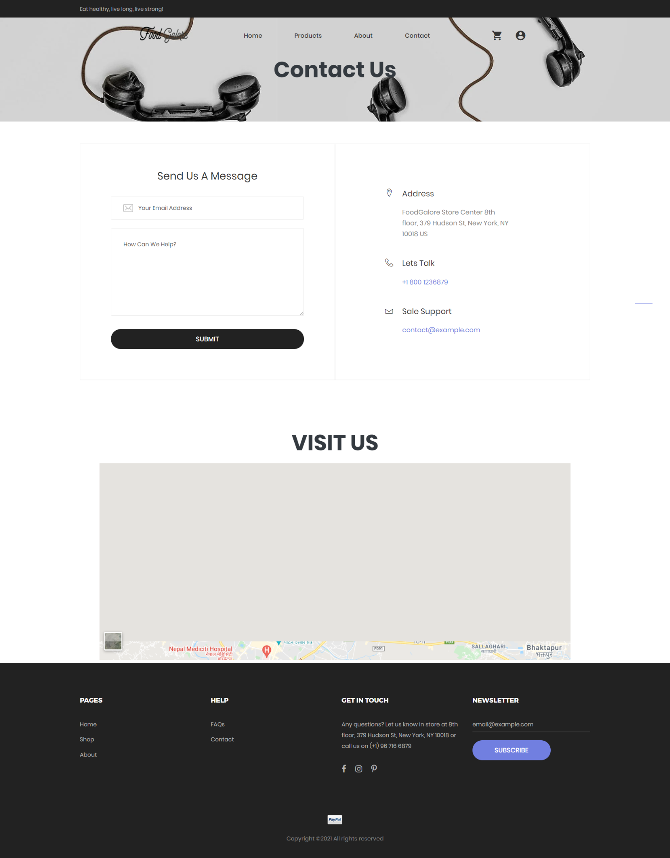

Action: Search and Sorting

Steps: Go to product page and sort according to name,price, popularity.

Expected Results: Sort appears.

Pass/Fail:Pass

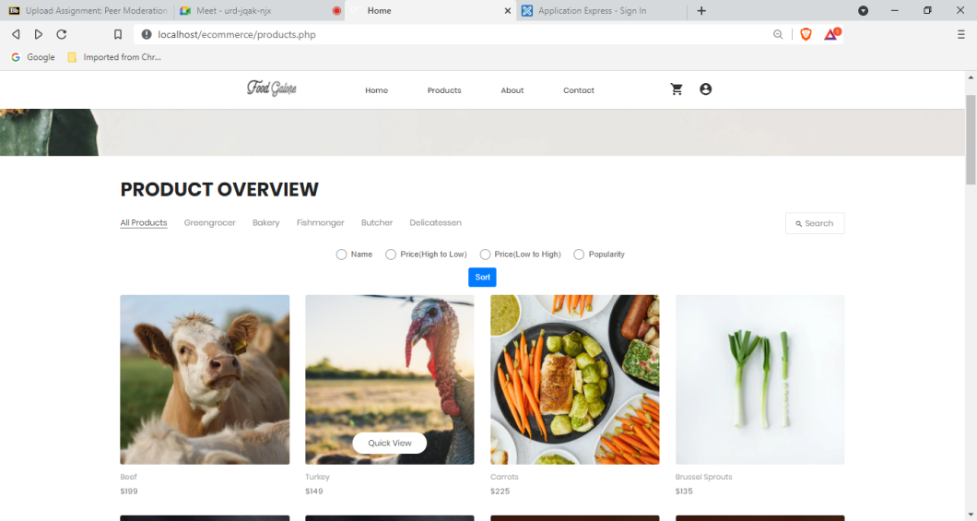

Action: FAQS

Steps: Click on faqs page.

Expected Results: You will be directed to the faq page.

Pass/Fail:Pass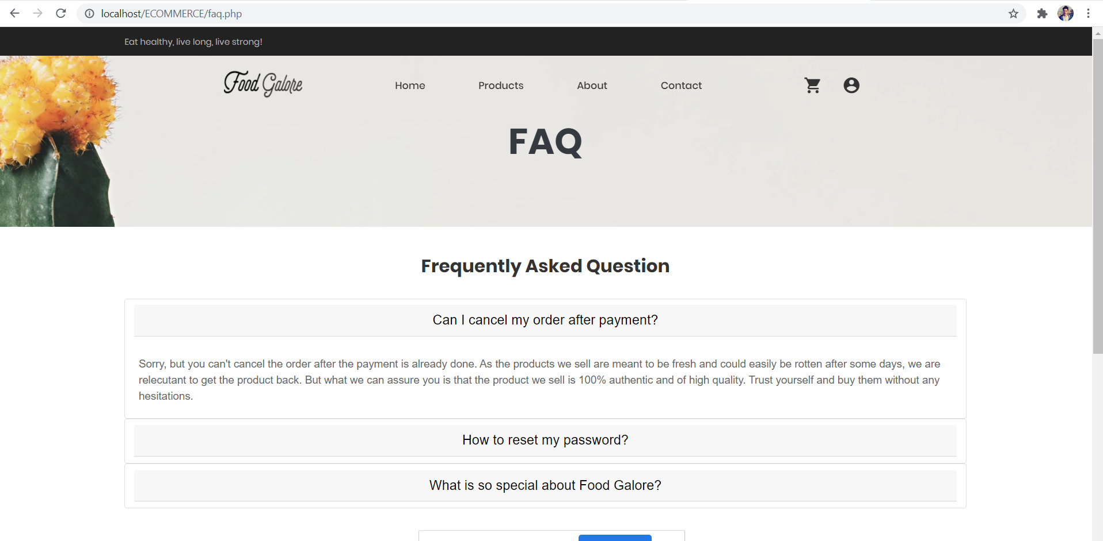

Action: Go to the Cart shown in the navigation

Steps: Click on navigation bar

Expected Results: You will be directed into Cart page

Pass/Fail: Pass

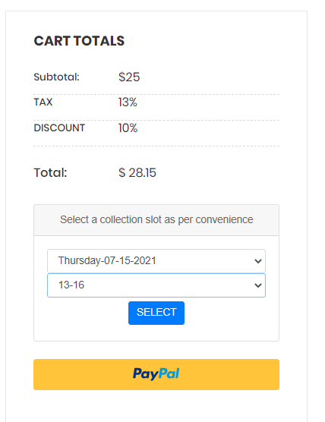

Action: Go and select your Collection Slot

Steps: Select your desirable slot and click select

Expected Results: You will have completed your payment

Pass/Fail: Pass

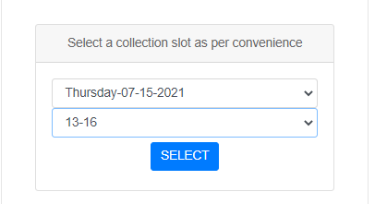

Action: Your payment will be completed

Steps: No step needed

Expected Results: A payment Success message pops up.

Pass/Fail: Pass

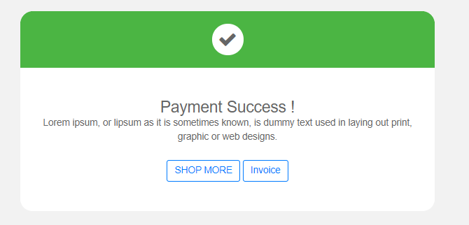

Action: When you go over to Invoice

Steps: Click on Invoice

Expected Results: Your total invoice will appear

Pass/Fail: Pass

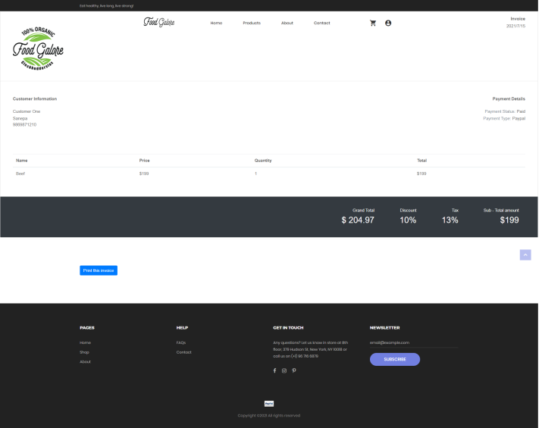

Action: Go to the Signout

Steps: Click on navigation bar and then logout

Expected Results: You will logout from the page

Pass/Fail: Pass

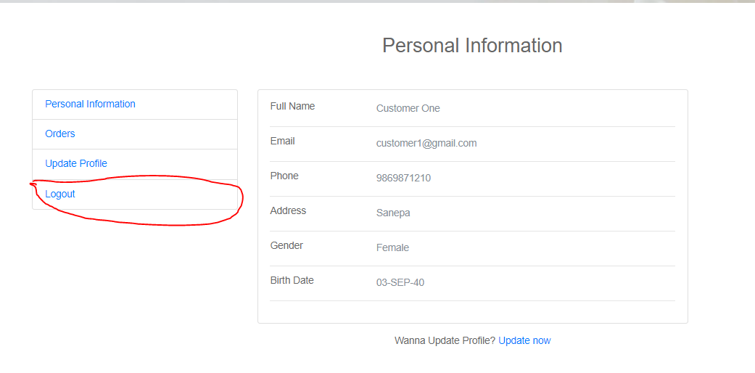

Action: View Order

Steps: Click on Order

Expected Results: You can see the orders made.

Pass/Fail: Pass

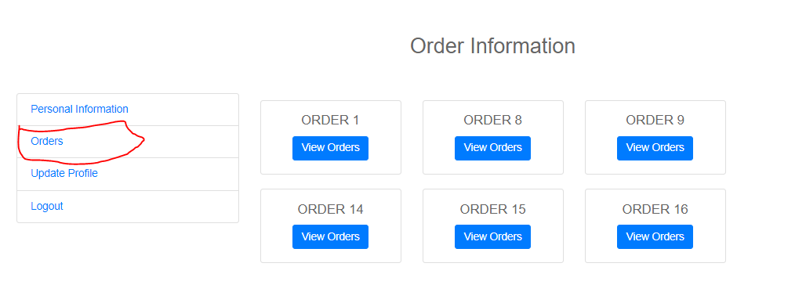

Action:View Update Profile

Steps: Go to Update Profile

Expected Results: You can Update your information

Pass/Fail:Pass

